SOFTWARE REQUIREMENT SPECIFICATION (SRS)
AI-Based Smart E-Waste Collection and Recycling Management Platform
Scenario-Based Requirement Analysis
Prepared for: CSA10 – Software Engineering | CO2 Assessment Tool 1

1. Introduction

1.1 Purpose
This Software Requirement Specification (SRS) document defines the functional and non-functional requirements for the AI-Based Smart E-Waste Collection and Recycling Management Platform. It provides a shared, unambiguous reference for stakeholders, developers, and quality-assurance teams throughout design, development, and validation.
The document translates the scenario into a structured specification, ensuring every stakeholder need is traceable to a concrete requirement, and every requirement is verifiable through testing or review.

1.2 Business Domain
The platform operates in the municipal solid-waste and environmental-technology domain, specifically addressing the collection, categorization, and responsible recycling of electronic waste (e-waste) generated by households, businesses, and institutions.
Improper disposal of e-waste causes soil and water contamination through hazardous materials such as lead, mercury, and cadmium, while also representing a lost opportunity to recover valuable metals and plastics. Governments worldwide are tightening Extended Producer Responsibility (EPR) regulations, increasing demand for verifiable, technology-driven collection and recycling systems.

1.3 Stakeholders
- Households and business clients who generate e-waste and require a convenient disposal channel.
- Collection agents who perform physical pickup and transport.
- Recycling facility operators who process collected material.
- Platform administrators who operate and monitor the system.
- Municipal and regulatory bodies who oversee compliance.
- Investors and platform operators funding the reward and incentive scheme.

1.4 Existing Challenges
- Low public awareness of proper e-waste disposal channels, leading to disposal in regular municipal waste.
- Manual, paper-based collection logs that make it difficult to trace material from pickup to final recycling.
- Inefficient, non-optimized collection routes that increase operating cost and vehicle emissions.
- Lack of verifiable proof of destruction/recycling for corporate clients with regulatory disposal obligations.
- Difficulty for municipal bodies in obtaining consolidated, accurate volume and compliance data.

1.5 System Objectives
- Provide a simple, app/web-based channel for scheduling e-waste pickups.
- Use AI-based image classification to assist accurate categorization of e-waste at the point of pickup.
- Optimize agent collection routes to reduce cost and carbon footprint.
- Maintain an auditable chain of custody from pickup through final recycling.
- Incentivize responsible disposal through a reward/points mechanism.
- Generate compliance-ready reports for regulatory bodies.

1.6 Success Metrics
- Increase in the volume (kg) of e-waste formally collected per month within the pilot zone.
- AI classification accuracy rate compared to manual facility-operator verification.
- Average reduction in agent travel distance/time achieved through AI route optimization.
- Percentage of pickups with a fully traceable chain-of-custody record ending in a certificate.
- User satisfaction score collected via the post-pickup feedback mechanism (FR-15).
- Rate of certificate issuance versus total collected batches, indicating end-to-end process completion.

2. Problem Description
Municipal authorities and private recyclers currently rely on fragmented, largely manual processes to collect and process e-waste from households and businesses. Citizens are often unaware of designated e-waste collection points or find the process inconvenient compared to simply discarding devices with general waste.
On the operational side, collection agents follow static or manually planned routes, resulting in wasted travel time and underutilized vehicle capacity. Once collected, items pass through recycling facilities with limited digital tracking, making it difficult to verify what percentage of collected material was actually recycled versus landfilled, and to produce credible compliance evidence for regulators or corporate clients with EPR obligations.
The proposed AI-Based Smart E-Waste Collection and Recycling Management Platform addresses these gaps by digitizing the entire lifecycle: on-demand pickup scheduling, AI-assisted item categorization, AI-optimized routing for agents, digital chain-of-custody logging at the facility, and automated compliance reporting — all supported by a citizen-facing reward mechanism to increase participation.
By closing the loop between collection and verified recycling, the platform aims to increase formal e-waste collection volumes, reduce informal/unsafe dismantling, and give municipal bodies reliable data for policy-making.

3. Scope of the System
The system scope covers a cloud-hosted platform accessible via native mobile applications (Android/iOS) and a responsive web portal, supported by backend microservices including booking management, an AI classification/routing engine, facility operations, reward/wallet management, and reporting/analytics.

3.1 In Scope
- User registration, pickup scheduling, and real-time tracking.
- AI-assisted image-based waste categorization and material-recovery estimation.
- Agent route optimization and mobile workflow for collection and delivery to facility.
- Facility intake logging and chain-of-custody traceability through to certificate generation.
- Reward/incentive management and compliance reporting for municipal bodies.

3.2 Out of Scope (Phase 1)
- Physical dismantling or material-processing machinery control (the platform is a management/software layer, not an industrial control system).
- Cross-border/international e-waste export documentation.
- Direct integration with third-party resale/refurbishment marketplaces (planned for a later phase).

4. Functional Requirements
The following table lists the functional requirements (FR) the system shall satisfy. This is the primary requirements traceability table referenced throughout the remainder of this document.
ID | Requirement | Description
FR-1 | User Registration & Profile Management | The system shall allow households, businesses, and institutions to register, verify their identity/address, and manage profile and address book details.
FR-2 | AI-Assisted Waste Categorization | The system shall allow a user to upload a photo of the e-waste item; an AI image-classification model shall identify the device category and hazard class.
FR-3 | Pickup Scheduling | The system shall allow users to schedule a collection request by selecting item categories, quantity, preferred date/time window, and pickup address.
FR-4 | AI Route Optimization | The system shall generate optimized daily collection routes for agents using an AI/heuristic routing engine considering location, vehicle capacity, traffic, and time windows.
FR-5 | Real-Time Pickup Tracking | The system shall provide users and administrators with real-time status updates and live agent location during transit.
FR-6 | Digital Weighing & Receipt Generation | The system shall allow the collection agent to record item weight/quantity at pickup and generate a digital collection receipt.
FR-7 | Reward / Incentive Management | The system shall calculate and credit reward points or cash-equivalent incentives based on the quantity and category of e-waste submitted.
FR-8 | Facility Intake Logging | The system shall allow facility operators to log incoming batches against originating pickup records for chain-of-custody traceability.
FR-9 | AI Sorting & Material Recovery Estimation | The system shall use an AI model to estimate recoverable material composition from item category and weight.
FR-10 | Recycling Certificate Generation | The system shall automatically generate a digital Certificate of Recycling/Destruction upon confirmed processing.
FR-11 | Compliance & Regulatory Reporting | The system shall generate periodic reports formatted for submission to municipal or pollution-control authorities.
FR-12 | Admin User & Facility Management | The system shall allow administrators to manage user accounts, agent assignments, facility onboarding, and role-based permissions.
FR-13 | Analytics Dashboard | The system shall provide dashboards showing collection volumes, AI classification accuracy, agent performance, and environmental impact.
FR-14 | Notifications & Alerts | The system shall send SMS/email/push notifications for booking confirmation, agent arrival, pickup completion, and reward credit.
FR-15 | Complaint & Feedback Management | The system shall allow users to rate the pickup experience and raise complaints routed to administrators for resolution tracking.

5. Non-Functional Requirements
The non-functional requirements (NFR) below define quality attributes the system shall satisfy, covering performance, security, reliability, usability, scalability, maintainability, and availability.
- NFR-1 (Performance): The system shall process AI-based image classification within 3 seconds per request and support at least 5,000 concurrent pickup requests during peak hours.
- NFR-2 (Scalability): The architecture shall scale horizontally to accommodate expansion from a single-city pilot to multi-city/national deployment without redesign.
- NFR-3 (Security): The system shall encrypt data in transit (TLS 1.2+) and at rest (AES-256), enforce role-based access control, and comply with applicable data-protection regulations.
- NFR-4 (Reliability): Core booking and tracking services shall maintain 99.5% uptime, with automated failover for critical microservices.
- NFR-5 (Usability): The mobile and web interfaces shall follow WCAG 2.1 AA accessibility guidelines and support at least two regional languages in addition to English.
- NFR-6 (Maintainability): The system shall be built using a modular, service-oriented architecture with documented APIs to allow independent updates to the AI models without downtime to core services.
- NFR-7 (Availability): The platform shall be accessible 24/7 for booking and tracking; scheduled maintenance windows shall not exceed 2 hours per month.
- NFR-8 (Interoperability): The system shall expose REST APIs to integrate with municipal waste-management systems and third-party logistics/payment providers.
- NFR-9 (Data Integrity & Traceability): The system shall maintain an immutable audit trail from pickup to final recycling/destruction for every logged item, supporting chain-of-custody verification.
- NFR-10 (Portability): Client applications shall run on Android, iOS, and modern web browsers with a responsive, consistent user experience.

6. Actors and Use Case Descriptions

6.1 Actors and Associated Use Cases

User / Household & Business Client (Primary)
- Register and manage account
- Schedule pickup via app/web portal
- Upload item photo for AI categorization
- Track pickup status in real time
- View reward points and redeem incentives
- Download recycling certificate
- Submit feedback or complaint

Collection Agent / Driver (Primary)
- View AI-optimized daily route
- Update pickup status (en-route, collected, cancelled)
- Record item weight/quantity at pickup
- Confirm collection and generate digital receipt

Recycling Facility Operator (Primary)
- Log received e-waste batch against pickup records
- View AI-based sorting and material-recovery estimates
- Update processing/recycling status
- Trigger certificate generation on completion

System Administrator (Primary)
- Manage user, agent, and facility accounts
- Configure roles and permissions
- Monitor analytics dashboard
- Manage AI model versions and thresholds

AI Classification / Routing Engine (Secondary – System)
- Classify uploaded item images into waste categories
- Estimate recoverable material composition
- Generate optimized collection routes

Municipal / Regulatory Body (Secondary)
- Receive periodic compliance and volume reports
- Audit chain-of-custody records

Payment / Wallet Gateway (Secondary – External System)
- Process reward redemption or cash-incentive payouts

6.2 Use Case Diagram
The diagram below shows the primary and secondary actors and their principal interactions with the system.
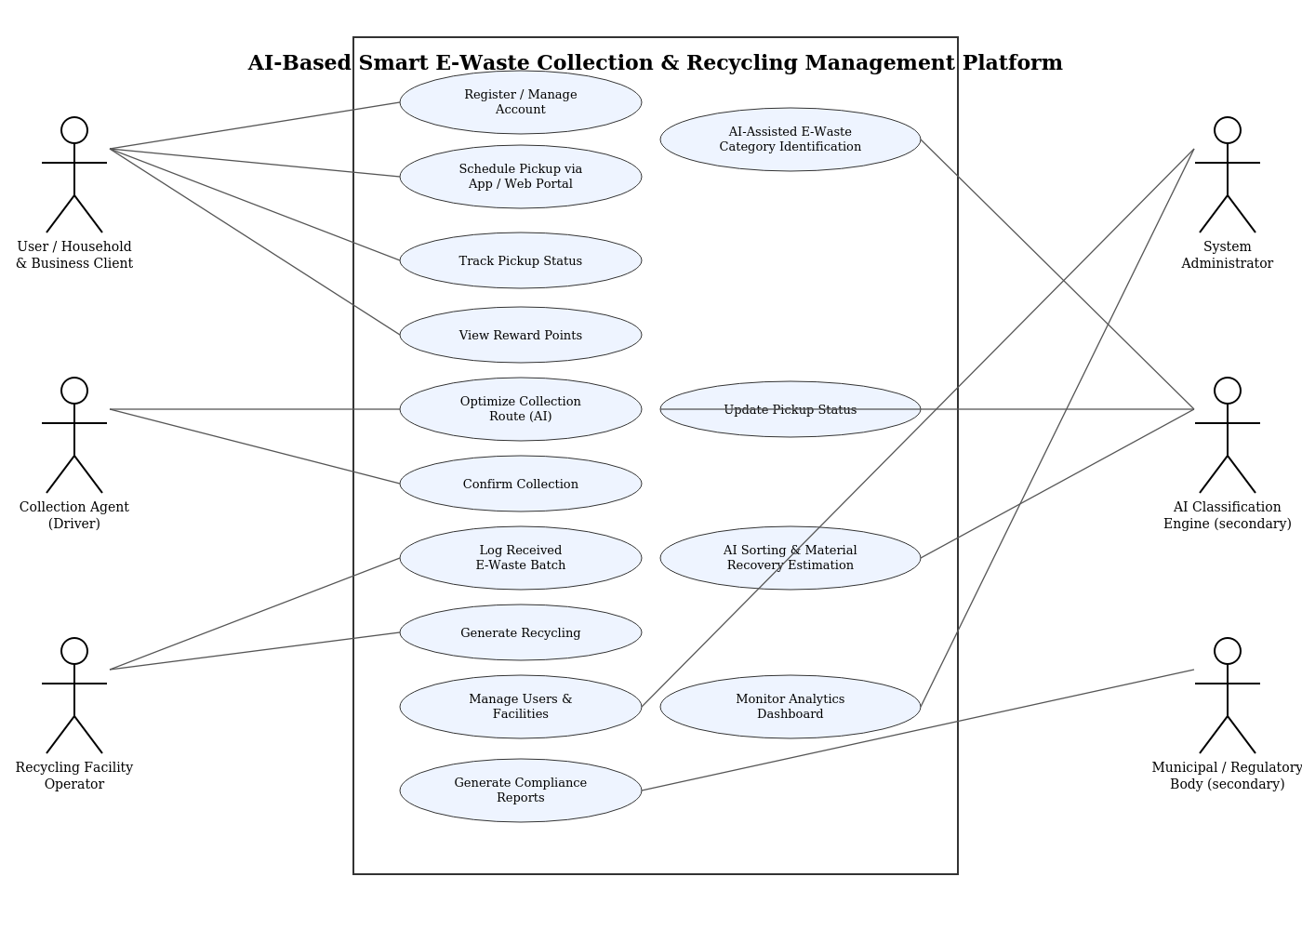

6.3 Detailed Use Case: Schedule Pickup via App/Web Portal
- Use Case ID / Name: UC-02 / Schedule Pickup via App/Web Portal
- Primary Actor: User (Household/Business Client)
- Preconditions: User is registered and logged in.
- Main Flow: 1. User selects 'New Pickup'. 2. User uploads a photo of the item(s). 3. AI engine suggests category and hazard class. 4. User confirms/edits category, enters quantity and address. 5. User selects a preferred time window. 6. System confirms the request and notifies the nearest available agent.
- Alternate Flow: If AI confidence is low, the system prompts the user to manually select a category from a guided list.
- Postconditions: A pickup request is created with status 'Requested' and appears in the agent's route queue.

6.4 Detailed Use Case: Log Received E-Waste Batch
- Use Case ID / Name: UC-09 / Log Received E-Waste Batch
- Primary Actor: Recycling Facility Operator
- Preconditions: Collection agent has marked the pickup as 'Collected' and delivered items to the facility.
- Main Flow: 1. Operator scans/enters the pickup receipt ID. 2. System retrieves linked item records. 3. Operator confirms received weight/quantity. 4. AI engine estimates recoverable material composition. 5. System updates chain-of-custody status to 'Received at Facility'.
- Alternate Flow: If a discrepancy exists between logged and received weight, the system flags the batch for administrator review.
- Postconditions: Batch is logged and linked to source pickups; status is available for compliance reporting and certificate generation.

6.5 Detailed Use Case: AI-Assisted Waste Categorization
- Use Case ID / Name: UC-03 / AI-Assisted Waste Categorization
- Primary Actor: AI Classification Engine
- Preconditions: User has uploaded at least one photo of the item during pickup scheduling.
- Main Flow: 1. Image is submitted to the classification service. 2. Model returns predicted category, hazard class, and confidence score. 3. Result is attached to the pickup request. 4. User reviews and confirms the suggested category.
- Alternate Flow: If confidence score is below the configured threshold, the system requests a clearer photo or manual selection.
- Postconditions: The pickup request carries a verified category used for routing, weighing, and material-recovery estimation downstream.

6.6 Detailed Use Case: Generate Compliance Report
- Use Case ID / Name: UC-14 / Generate Compliance Report
- Primary Actor: System Administrator (on behalf of Municipal/Regulatory Body)
- Preconditions: A reporting period (e.g., monthly/quarterly) has elapsed and facility batch data is finalized in the system.
- Main Flow: 1. Administrator selects the reporting period and facility/region scope. 2. System aggregates volume, category-wise breakdown, and hazardous-material handling data. 3. System compiles the data into the regulator's required report format. 4. Administrator reviews and submits the report to the Municipal Compliance Portal.
- Alternate Flow: If data for any facility is incomplete for the period, the system flags the gap and excludes that facility's figures from the submitted report until resolved.
- Postconditions: A compliance report is generated, logged, and available for audit; the Municipal/Regulatory Body receives the submission.

6.7 Detailed Use Case: Redeem Reward Points
- Use Case ID / Name: UC-07 / Redeem Reward Points
- Primary Actor: User (Household/Business Client)
- Preconditions: User has accumulated a reward-point balance greater than the minimum redemption threshold.
- Main Flow: 1. User opens the reward wallet screen. 2. System displays current point balance and redemption options (cash payout, vouchers). 3. User selects a redemption option and confirms. 4. System calls the Payment/Wallet Gateway to process the payout and deducts the redeemed points.
- Alternate Flow: If the payment gateway call fails, the system rolls back the point deduction and notifies the user to retry.
- Postconditions: Reward points are deducted, a transaction record is created, and the payout is confirmed to the user.

7. Process Flow Chart
The flow chart below illustrates the end-to-end process flow of the system, from user registration through pickup, AI classification, collection, facility processing, and final certificate/compliance reporting.
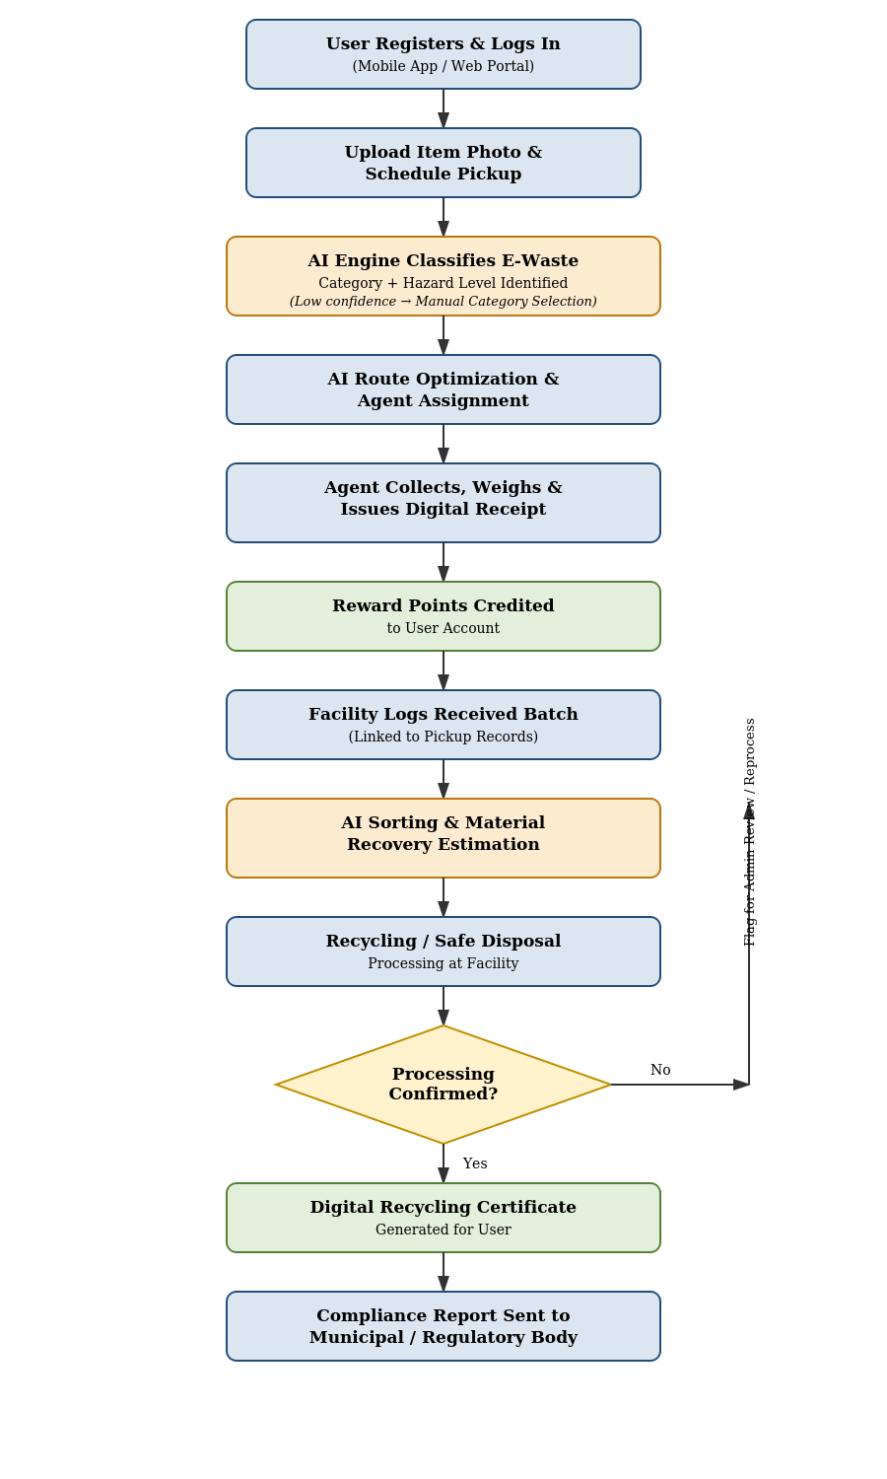

8. Data Requirements
- User Data: Name, contact number, email, address(es), registration date, verification status, reward-point balance.
- Pickup Request Data: Request ID, user ID, item category(ies), estimated quantity/weight, preferred time window, status, assigned agent ID, geolocation.
- Item / Batch Data: Item ID, category, sub-category, hazard classification, weight, AI confidence score, linked pickup request ID, facility batch ID.
- Facility Data: Facility ID, name, address, license/registration number, capacity, certified processes (recycle/refurbish/dispose).
- AI Model Data: Model version, training dataset reference, classification confidence thresholds, inference logs.
- Transaction & Reward Data: Reward transaction ID, points earned/redeemed, payout amount, payment gateway reference.
- Compliance & Audit Data: Chain-of-custody log entries, timestamps, certificate IDs, report generation history.
All data entities above are linked through the Pickup Request ID as the primary correlation key, allowing the system to reconstruct the full journey of any item — from the moment a user schedules a pickup to the moment a recycling certificate is issued — for audit, dispute resolution, and regulatory reporting purposes. Historical data is retained according to the data-retention policy defined under the applicable data-protection regulation, and access to each entity is restricted by the role-based permissions defined for each actor in Section 6.

9. External Interface Requirements
- Mobile Application (Android/iOS): User interface for booking, tracking, notifications, and reward wallet.
- Web Portal: User interface for booking, admin dashboard, and facility operations console.
- Maps & Geolocation API: External system for address geocoding, live agent tracking, and route optimization input.
- SMS / Email / Push Notification Gateway: External system for transactional alerts and status updates.
- Payment Gateway: External system for reward redemption / cash-incentive disbursal.
- Municipal Compliance Portal: External system for submission of periodic regulatory reports (API or file-based).
- AI Model Serving API: Internal interface for image classification and material-recovery estimation microservice.
All external interfaces are versioned and documented via an API specification, allowing municipal partners and third-party providers to integrate without direct access to internal system components. Interfaces that exchange personal or transaction data enforce the same encryption and access-control requirements defined under NFR-3.

10. System Features
- Smart Pickup Scheduling: Guided booking flow with AI-assisted category detection from a photo, reducing manual data entry and misclassification.
- Live Tracking & Notifications: Map-based live tracking of the collection agent with proactive SMS/push updates at each status change.
- Reward & Incentive Engine: Configurable point-based incentive system to encourage responsible e-waste disposal, with in-app redemption.
- AI-Optimized Routing: Daily route generation for agents that minimizes travel distance and balances vehicle load across pickups.
- Traceability & Digital Certification: End-to-end chain-of-custody logging from pickup to recycling, culminating in a verifiable digital certificate.
- Compliance Reporting: Automated, scheduled generation of regulatory reports for municipal/pollution-control authorities.
- Analytics Dashboard: Role-based dashboards showing volumes, environmental impact, agent performance, and AI accuracy metrics.
- Chain-of-Custody Certificate Vault: A secure, searchable archive of all issued recycling certificates that users and corporate clients can access on demand for their own audit or EPR reporting needs.
- Multi-Language Support: Localized content in English plus at least two regional languages to widen adoption among household users across different regions.
- Facility Capacity Planning: A forecasting view that projects expected incoming volume per facility based on scheduled pickups, helping operators plan staffing and processing capacity in advance.
- Agent Performance Scorecard: A summary view for administrators showing each agent's completed pickups, average route efficiency, and customer ratings over a selected period.

11. Assumptions and Constraints

11.1 Assumptions
- Users have access to a smartphone or web browser and a stable internet connection to use the platform.
- Collection agents are equipped with GPS-enabled mobile devices for live tracking and status updates.
- Partner recycling facilities possess valid regulatory licenses and are willing to integrate with the platform's logging system.
- A labeled image dataset of common e-waste categories is available or can be curated to train the AI classification model.
- Reward payouts are subject to a fixed budget defined by the platform operator or sponsoring municipal body.
- Users provide reasonably accurate item information; AI classification serves as an assistive check rather than a fully autonomous decision in the pilot phase.

11.2 Constraints
- Technical: The AI classification model's accuracy depends on image quality and lighting conditions supplied by users; low-confidence results require manual review.
- Operational: Agent availability and vehicle capacity limit the number of same-day pickups per zone.
- Economic: The reward/incentive scheme must operate within an approved budget, which may cap growth in participation.
- Legal / Regulatory: The platform must comply with regional e-waste management rules and data-protection legislation, and only partner with licensed recycling facilities.
- Time-Related: Pilot deployment is targeted for a single city/zone before phased national rollout; the AI model must be trained and validated within this window.
- Environmental: The collection vehicle fleet and facility processes must adhere to local emissions and hazardous-handling standards, which may limit fleet size or facility throughput during the pilot.
- Resource / Staffing: Availability of trained facility staff to validate AI sorting recommendations may constrain the throughput of the AI Sorting & Material Recovery Estimation feature (FR-9) in early phases.

12. Validation of Requirement Completeness and Consistency
The requirement set above was reviewed against the following criteria to check for ambiguity, redundancy, inconsistency, and missing coverage.
- Completeness: All actor–use-case pairs identified in Section 6 are traceable to at least one functional requirement (FR-1 to FR-15).
- Consistency: Terminology for 'pickup request', 'batch', and 'certificate' is used uniformly across all sections to avoid ambiguity between similar concepts.
- Ambiguity: Quantitative NFRs (e.g., NFR-1 response time, NFR-4 uptime) replace vague terms such as 'fast' or 'reliable' with measurable targets.
- Redundancy: Reward calculation logic is defined once (FR-7) and referenced elsewhere rather than restated, avoiding conflicting definitions.
- Verifiability: Each functional requirement is stated so that a test case can be derived (e.g., FR-2 classification response time is testable against NFR-1).
- Missing Requirements (identified during review): Added FR-15 (complaint/feedback) and NFR-9 (traceability) after review, as the initial draft covered forward flow (pickup → recycling) but omitted service-quality and audit concerns.

12.1 Suggested Improvements
- Introduce a formal AI-confidence threshold policy (e.g., below 80% confidence always routes to manual category selection) to remove ambiguity in FR-2 and UC-03.
- Add a data-retention and right-to-erasure clause to NFR-3 to strengthen alignment with data-protection regulations.
- Define explicit SLA escalation steps for NFR-4 (reliability) so 'failover' is measurable and testable during acceptance testing.
- Pilot the reward-point conversion rate with a small user group before city-wide rollout to validate the economic constraint assumptions in Section 11.
- Conduct a formal walkthrough with municipal stakeholders to validate that compliance report fields (Section 9) match statutory reporting formats.

12.2 Traceability Summary
Every functional requirement in Section 4 maps to at least one actor and use case in Section 6, at least one process step in the flow chart in Section 7, and at least one data entity in Section 8. This closed loop of traceability — from stakeholder need, to requirement, to use case, to process step, to data entity — is what was checked during the completeness and consistency review documented above, and is the basis on which this SRS is considered ready for design handoff.
Any future change request against this document should be evaluated for its downstream impact across all four of these layers (requirement, use case, process flow, and data model) before being approved, to preserve the consistency validated in this section.

12.3 Document Revision & Sign-off
This SRS represents the first complete draft prepared for the CO2 Assessment Tool 1 scenario-based requirement analysis exercise. It is intended to be reviewed and, where necessary, revised following stakeholder feedback before being used as the baseline for architecture and design activities.
- Version: 1.0 – Initial complete draft
- Status: Ready for stakeholder review
- Prepared By: Student, CSA10 – Software Engineering
- Next Step: Peer/faculty review against the assessment rubric, followed by incorporation of feedback into Version 1.1

